

**AI Data Powered Analysis Early Internship - Sub-Group 7**

**Week-1 Final Report**

**Report Title: “Week-1: Data Cleaning and Feature Engineering Report”**

**Associate Members:**

| **Name** | **Email** |
| --- | --- |
| Kolawole Oparinde | [kolawole@vempower.org](mailto:kolawole@vempower.org) |
| Akanksha Choudhary | [akanksha@vempower.org](mailto:akanksha@vempower.org) |
| Sakshi Sahu | [sakshisahu@vempower.org](mailto:sakshisahu@vempower.org) |
| Shishir Jaiswal | [shishir@vempower.org](mailto:shishir@vempower.org) |
| Shruti Mishra | [shrutimishra@vempower.org](mailto:shrutimishra@vempower.org) |

**Team Members:**

| **Name** | **Role** | **Email** |
| --- | --- | --- |
| Sumaiya Tasnim | Team Lead | [sumaiyaa.tasnim.18@gmail.com](mailto:sumaiyaa.tasnim.18@gmail.com) |
| Saniya Dantal | Project Scribe | [dantalsb04@gmail.com](mailto:dantalsb04@gmail.com) |
| Zaheer 123 | Project Manager | [mianzaheer4195@gmail.com](mailto:mianzaheer4195@gmail.com) |
| Devadharshini T | Project Lead | [dharshinideva83@gmail.com](mailto:dharshinideva83@gmail.com) |
| Peter Macharia | Team Member | [mpeter778@gmail.com](mailto:mpeter778@gmail.com) |
| Bokka Hamsini | Team Member | [bokkahamsini@gmail.com](mailto:bokkahamsini@gmail.com) |

**Introduction :**

The first week of the AI Data Powered Analysis Early Internship with Excelerate will focus on building a strong foundation in data science through Python programming, data preprocessing, and feature engineering. The activities will include collecting and cleaning datasets, handling missing values, removing duplicates, and creating new features to capture deeper insights into learner engagement. Feature engineering will involve deriving new variables, transforming existing ones, and extracting trends to enhance the quality and utility of the data. These steps will help analyze engagement patterns, predict drop-offs, identify influencing factors, and optimize program strategies, preparing well-organized datasets for advanced analysis in the following weeks.

**Objectives :**

* Understand the fundamentals of data science and Python essentials.
* Explore the dataset and identify issues such as missing values, outliers, duplicates, and inconsistencies.
* Perform systematic data cleaning and validation to ensure dataset quality.
* Apply feature engineering techniques to create meaningful new features.
* Document the cleaning and preprocessing process in a structured report.

**Assigned Dataset : “SLU_Opportunity_Wise_Data.csv”**

**Tools We Will Use :**

* **Python & Libraries**: Pandas, NumPy, Scikit-learn, re, missingno etc (for cleaning and preprocessing) in Visual studio/Google Colab.
* **Excel**: For basic feature creation, normalization, and categorical encoding.
* **Documentation Tools**: Word/Google Docs for compiling reports.

**Expected Outcomes**

* A cleaned and preprocessed dataset free from errors, duplicates, and inconsistencies.
* Newly engineered features (e.g., age calculation, engagement duration, normalized metrics).
* A comprehensive Week 1 report outlining dataset structure, cleaning methods, and feature engineering steps.

**Learning Outcomes**

1. Gain familiarity with dataset exploration and preprocessing workflows.
2. Develop practical skills in Python and Excel for cleaning and transforming data.
3. Strengthen analytical thinking by solving real-world data issues.
4. Improve technical communication through structured reporting.
5. Lay the groundwork for advanced analytics and predictive modeling in subsequent weeks.

**Understanding The Dataset**

**Exploring Dataset:**

| **Column Names** | **Datatypes** | **Identify key Variables** | **Why it matters** |
| --- | --- | --- | --- |
| Learner SignUp DateTime | TIMESTAMP | Timeline key | Helps track lifecycle and progress of applications. |
| Opportunity Id | VARCHAR(50) | Primary key for opportunities | Uniquely identifies each opportunity record. |
| Opportunity Name | TEXT | Categorical key | Defines type and details of the opportunity. |
| Opportunity Category | TEXT | Categorical key | Defines type and details of the opportunity. |
| Opportunity End Date | TIMESTAMP | Timeline key | Helps track when opportunities close. |
| First Name | TEXT | Demographic key | Identifies participants, useful for mapping learner-specific data. |
| Date of Birth | DATE | Demographic key | Provides age-related insights, helps with eligibility checks. |
| Gender | VARCHAR(20) | Demographic key | Supports diversity and demographic analysis. |
| Country | VARCHAR(100) | Demographic key | Indicates geographic distribution of learners. |
| Institution Name | TEXT | Academic key | Shows institutional affiliations, useful for partnerships and analysis. |
| Current/Intended Major | TEXT | Academic key | Provides academic background for opportunity relevance analysis. |
| Entry created at | TIMESTAMP | Timeline key | Tracks when entries were logged into the system. |
| Status Description | TEXT | Process tracking | Describes learner’s current status in the opportunity lifecycle. |
| Status Code | INTEGER | Process tracking | Numeric representation of learner’s status, useful for analytics. |
| Apply Date | TIMESTAMP | Timeline key | Tracks when learners applied for opportunities. |
| Opportunity Start Date | TIMESTAMP | Timeline key | Indicates when opportunities begin, helps in scheduling and planning. |

Total Columns : 16

Total Records: 8558 rows

**Perfoming Data Cleaning & Validation**

Data cleaning and validation involve identifying and correcting errors, inconsistencies, and missing values to ensure the dataset is accurate and reliable. It is important because high-quality data improves the validity of analysis, enhances decision-making, and prevents misleading results.

**Data Cleaning Process:** Using *Python Programming Language* in Visual Studio:

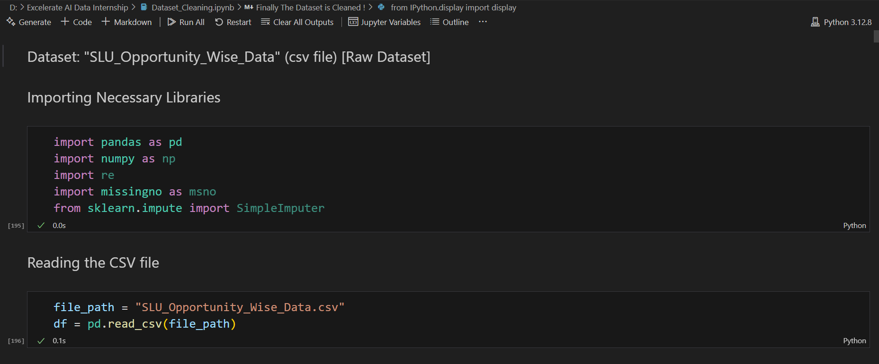

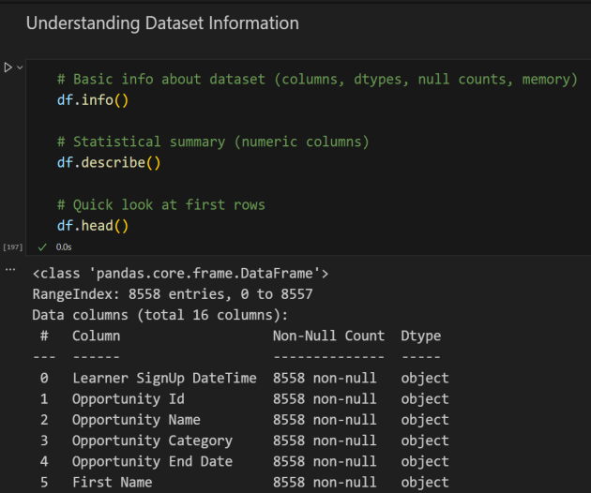 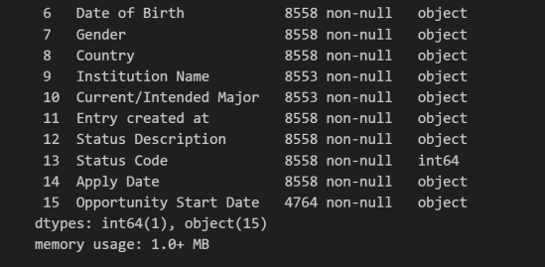

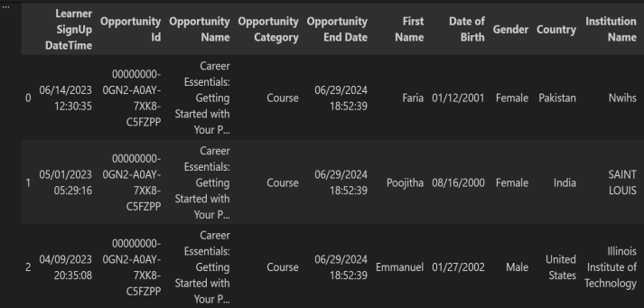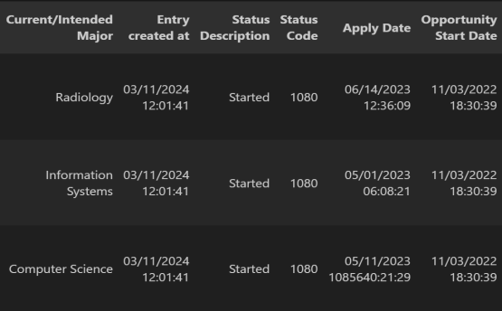

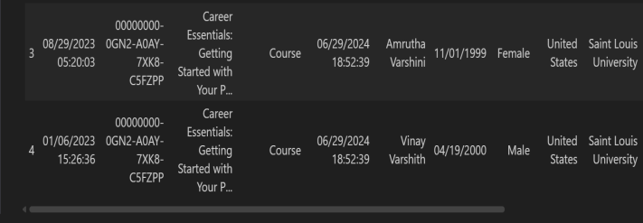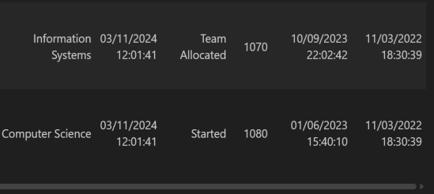

1. **Handling Missing & NULL Values:**

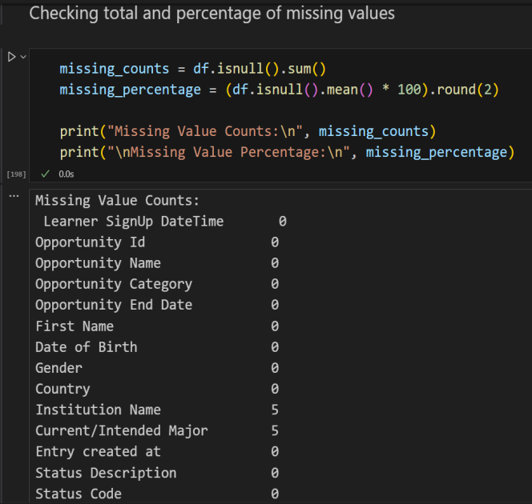 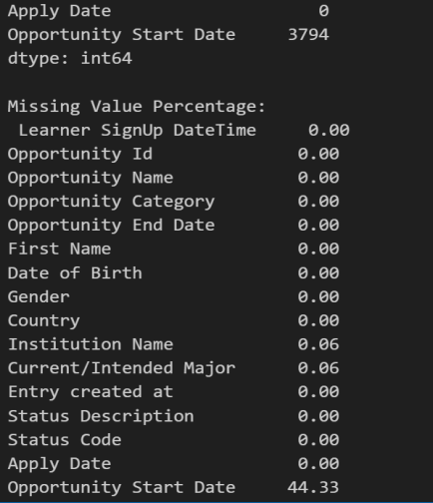

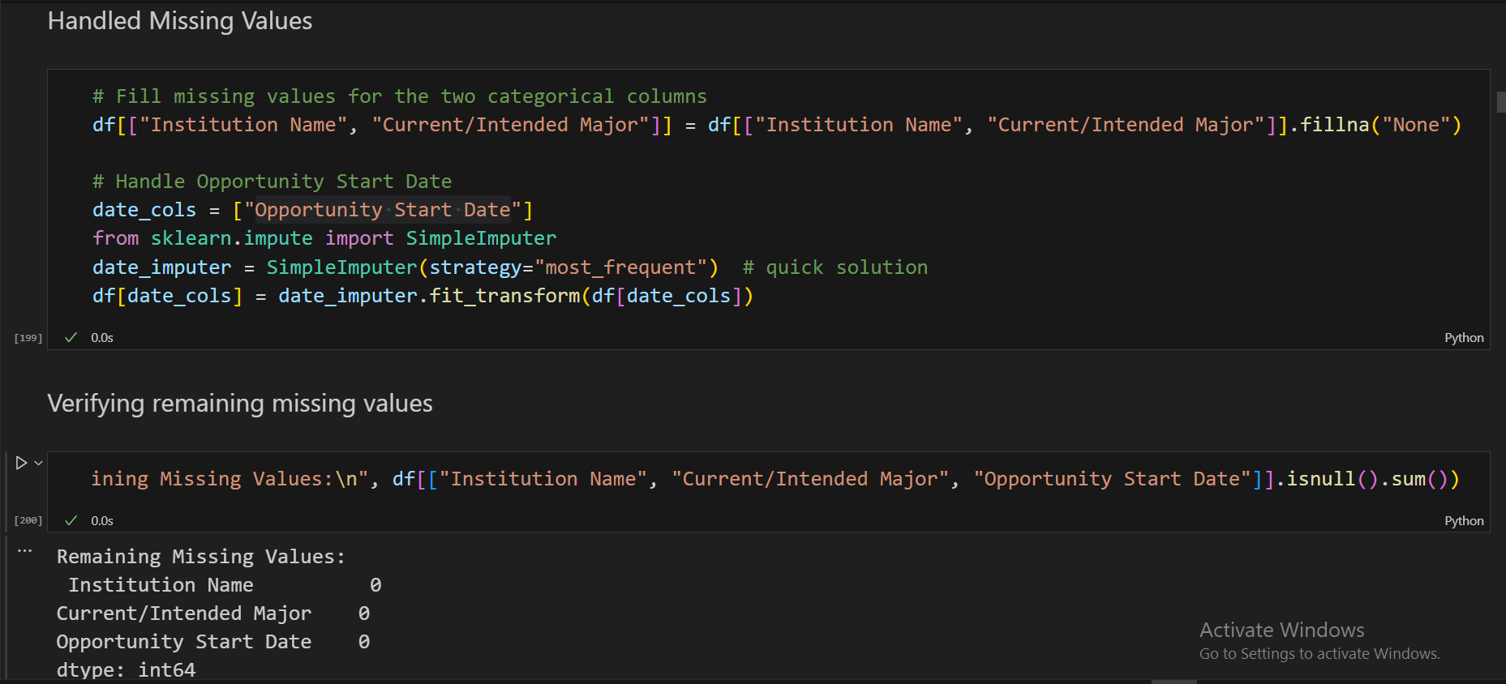

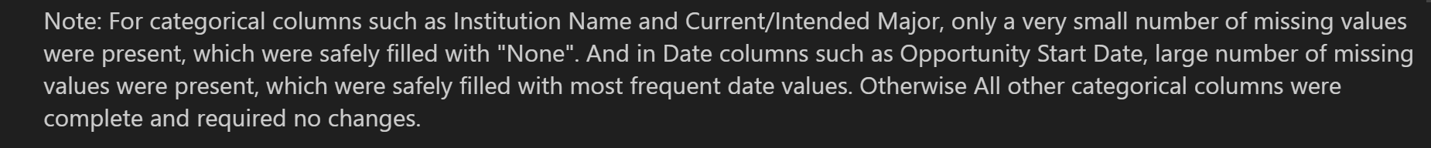

1. **Handling Outliers:**

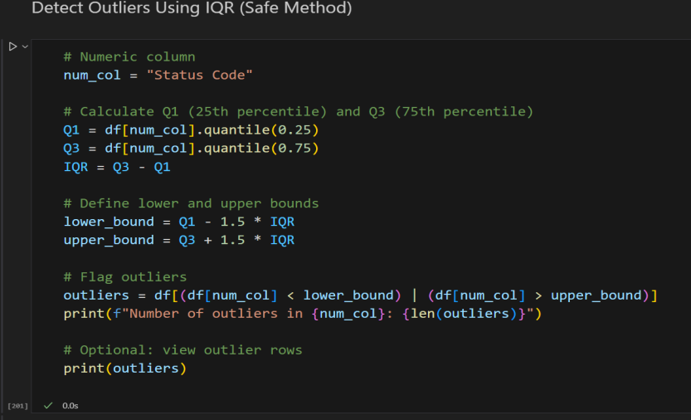

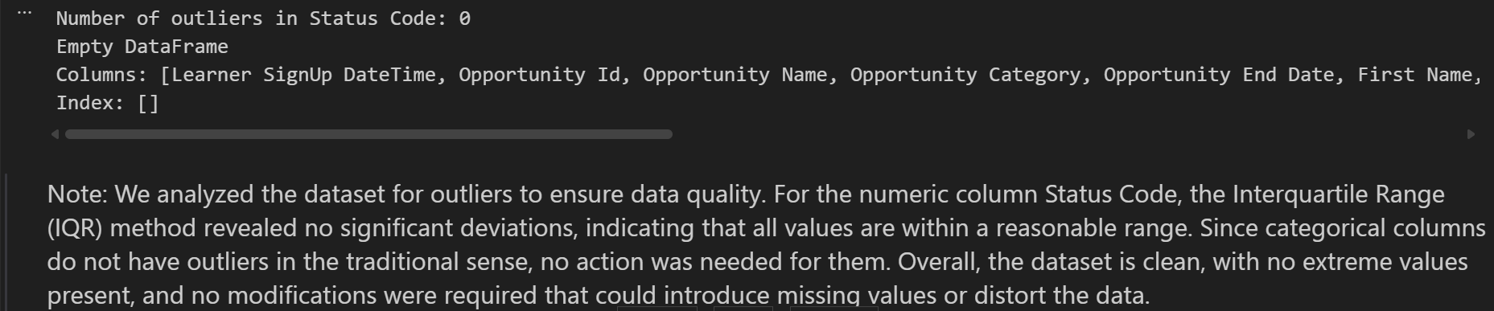

1. **Standardizing Formats:**

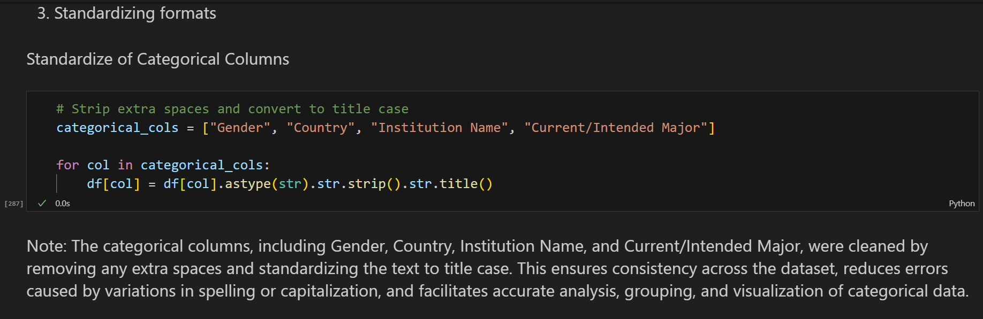

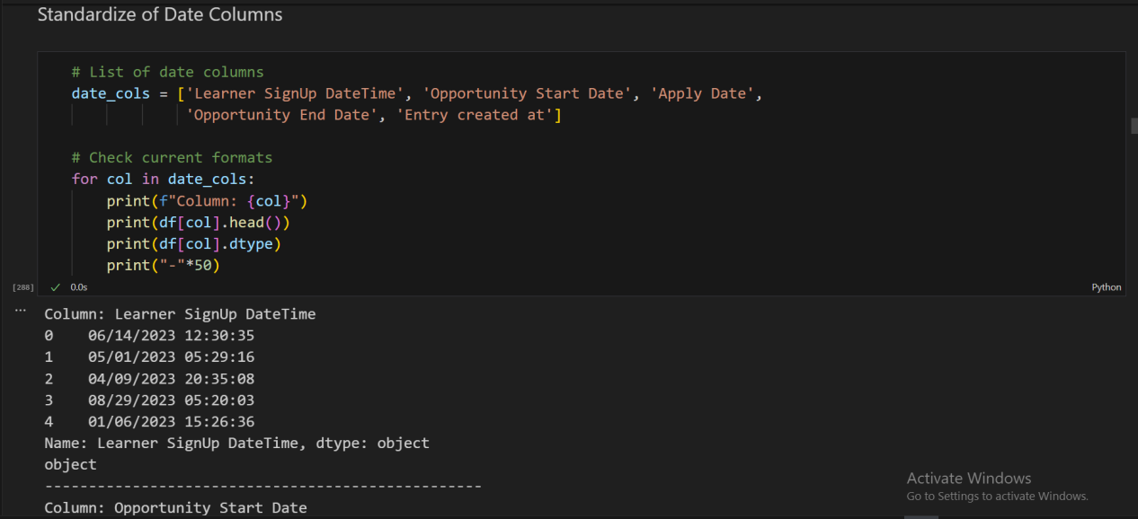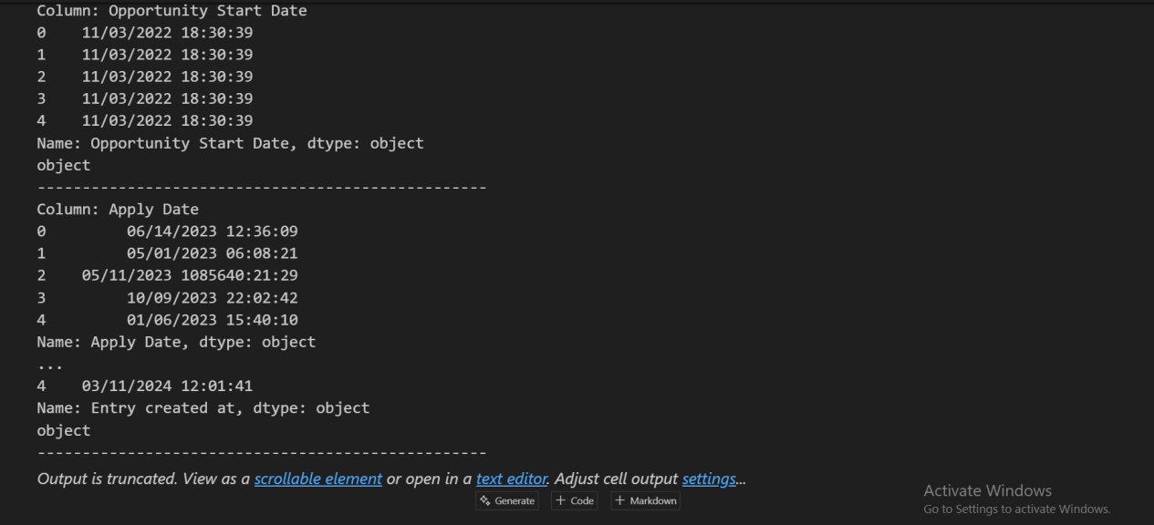

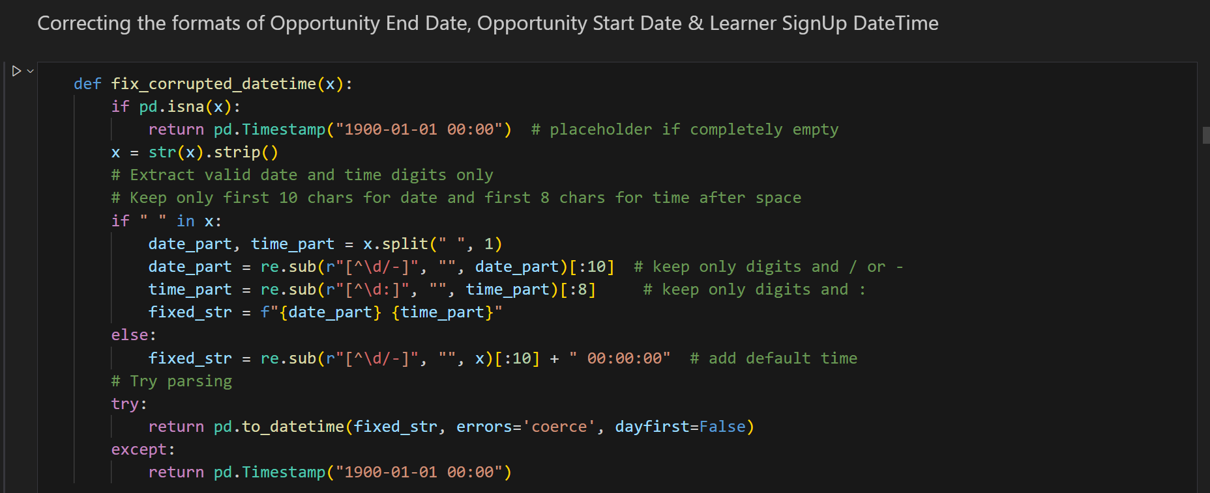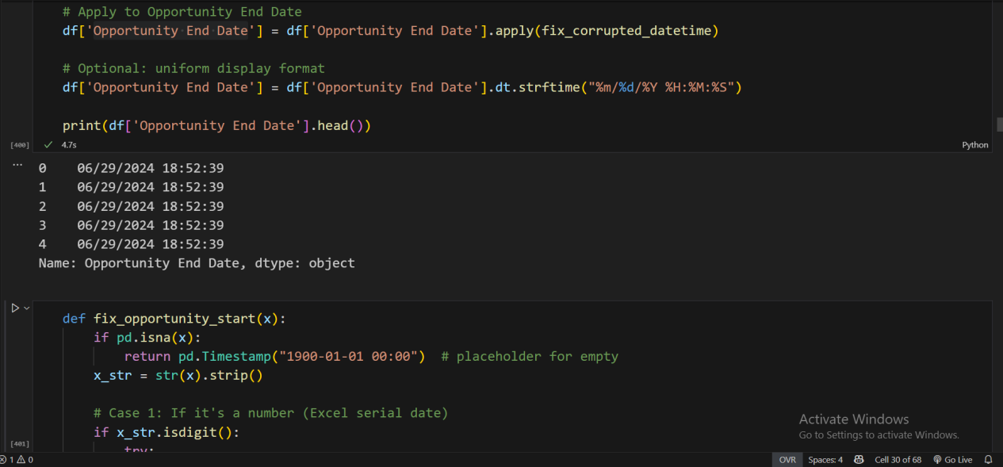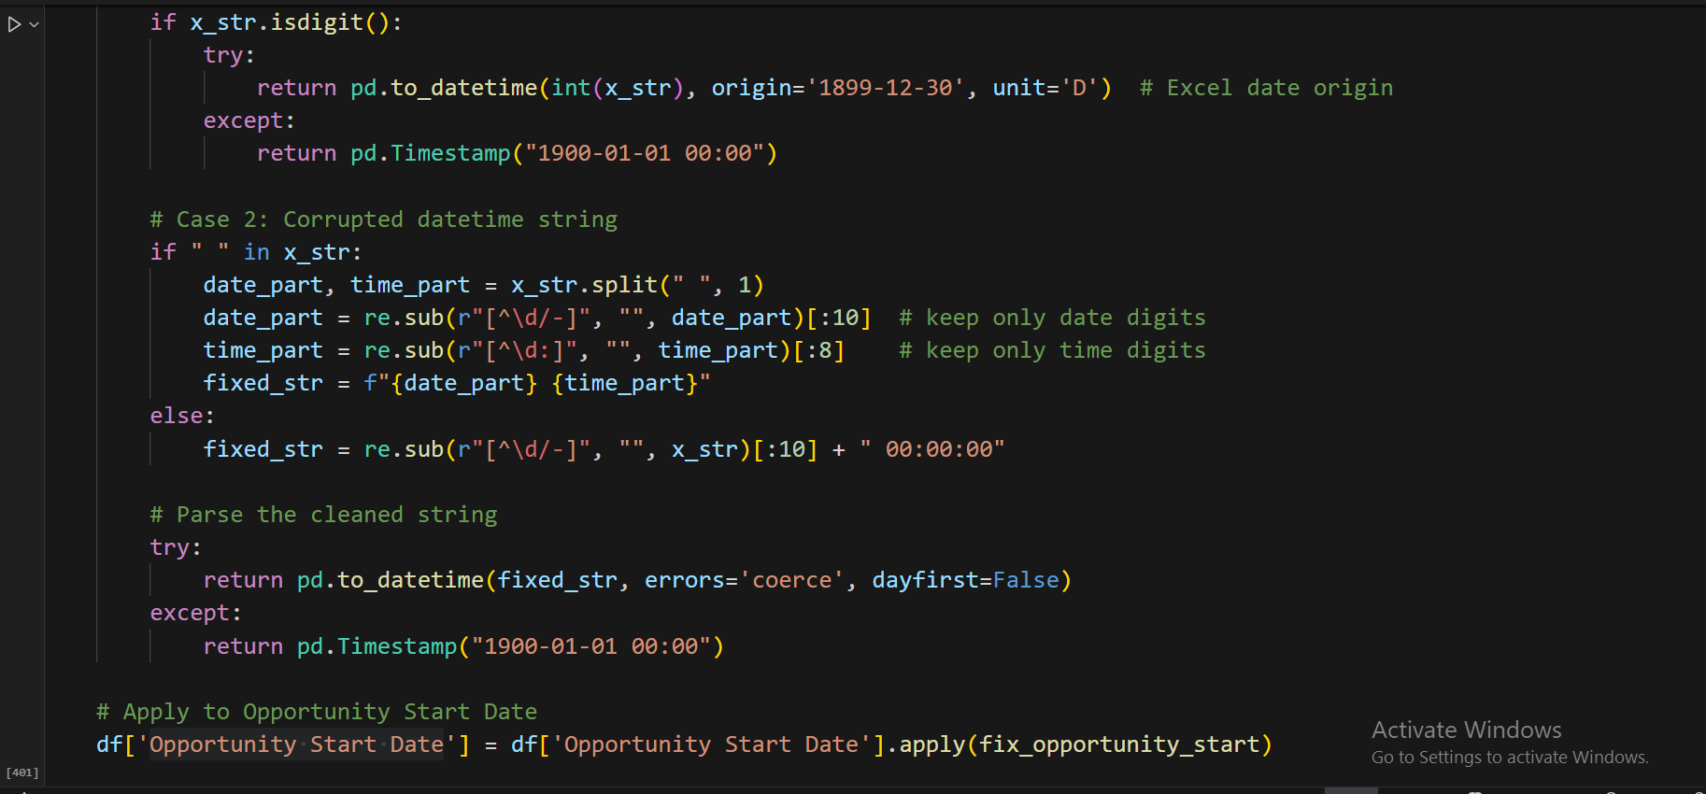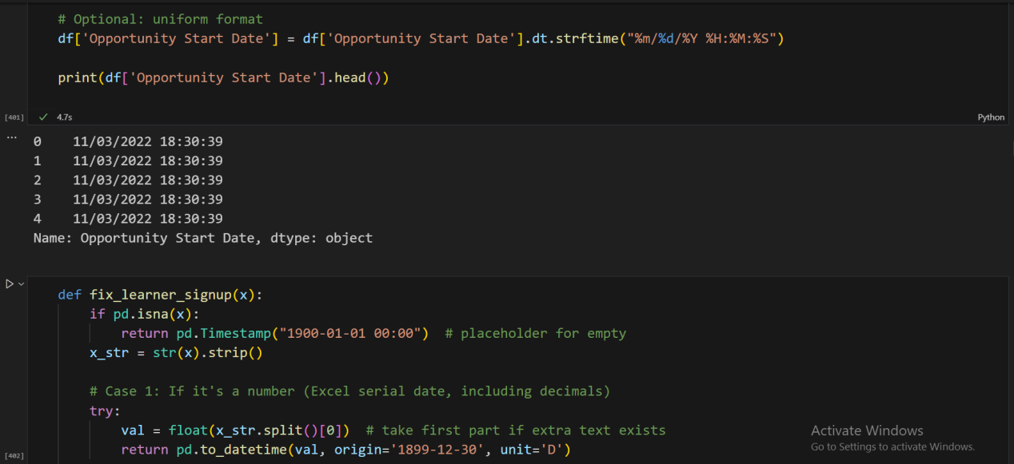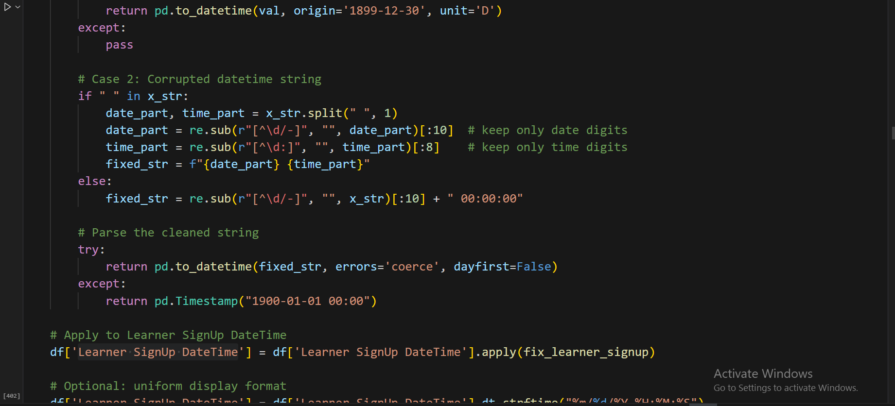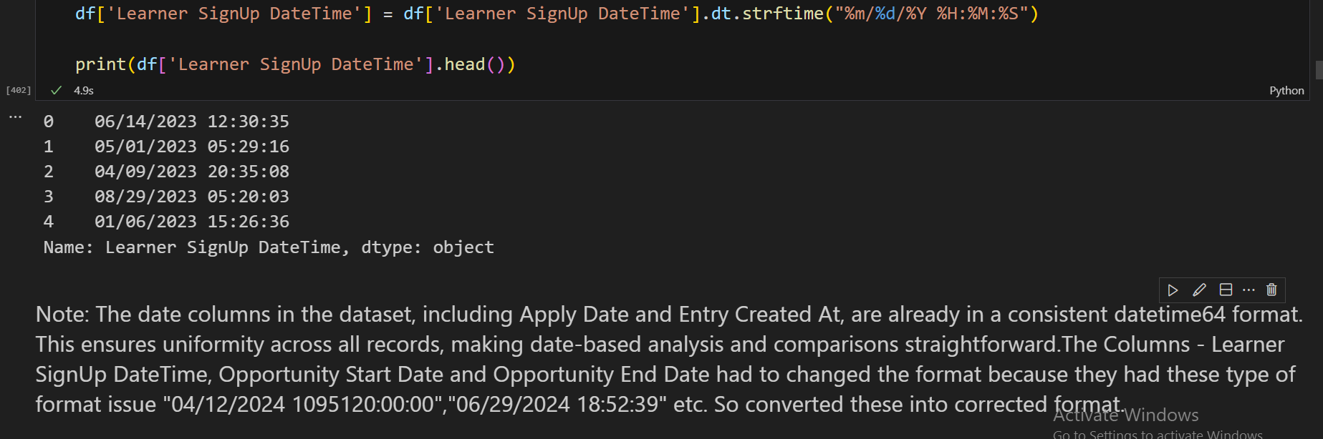

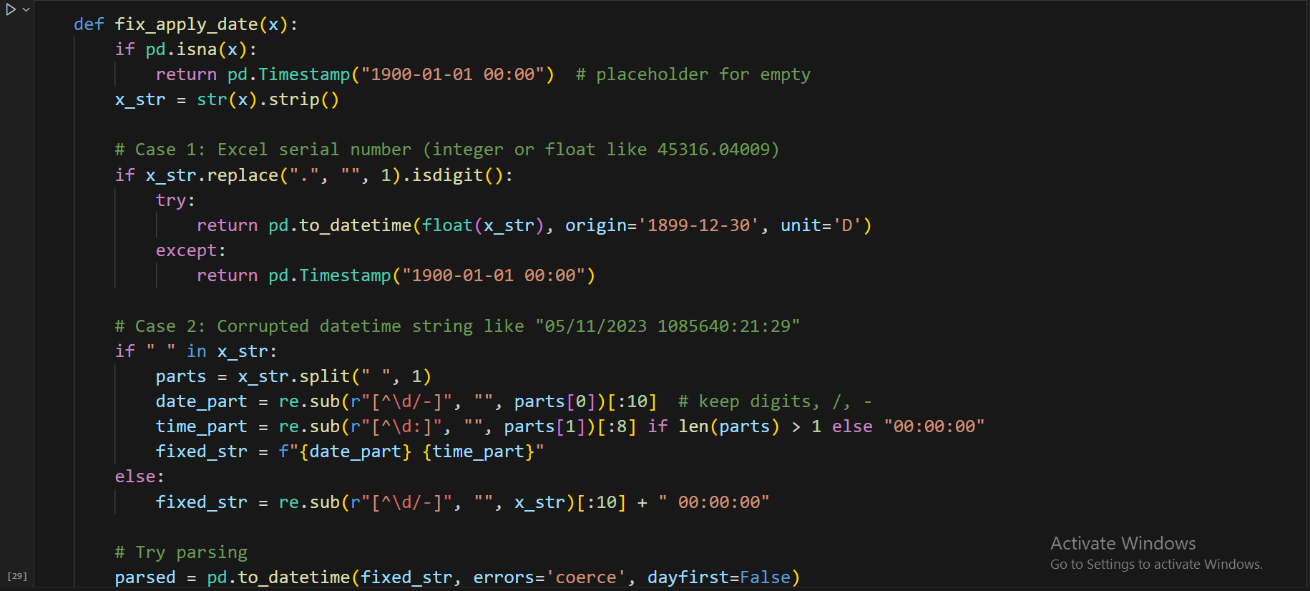

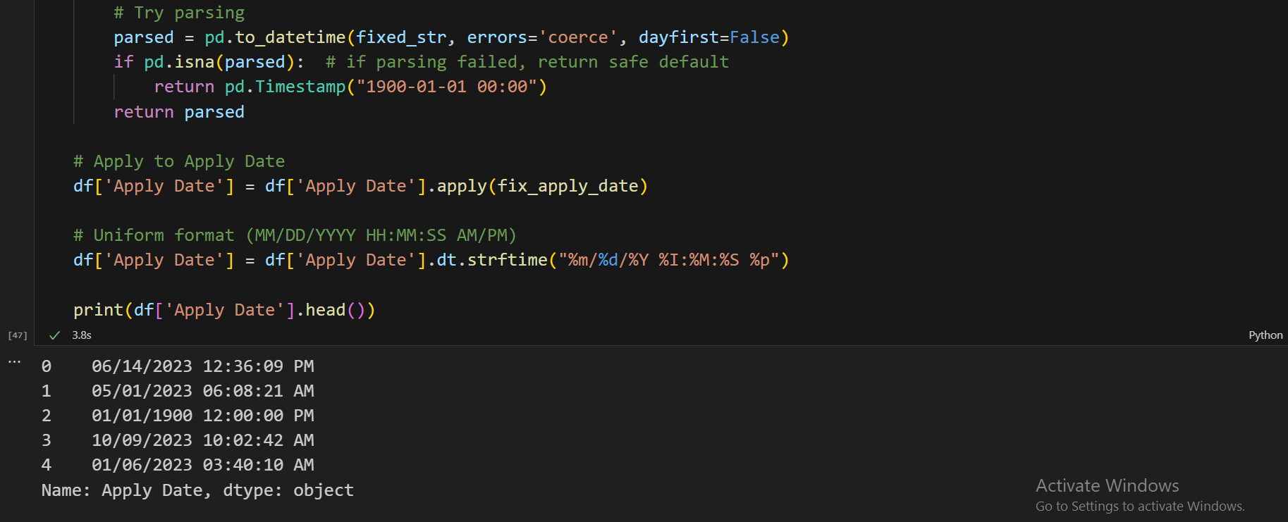

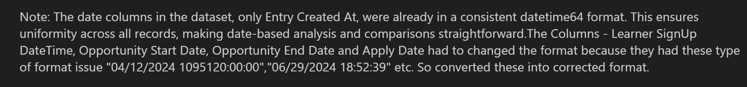

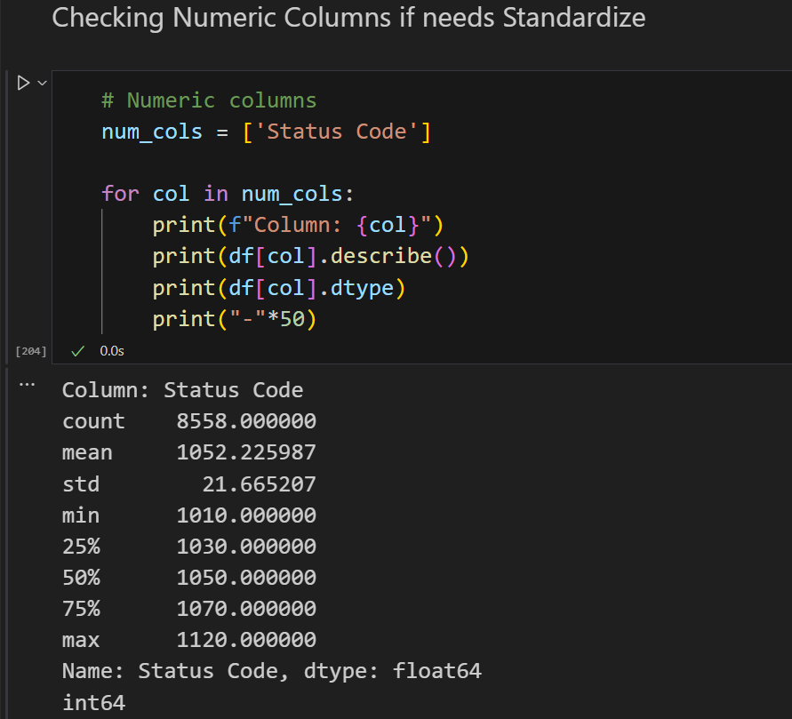



1. **Correcting Errors:**

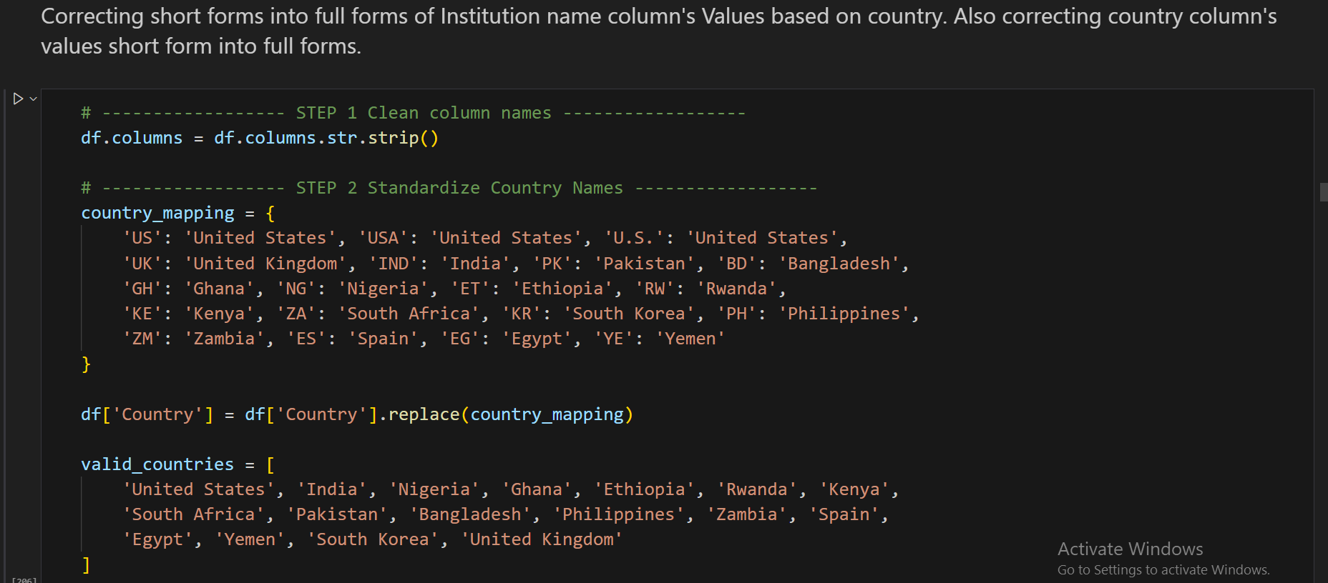

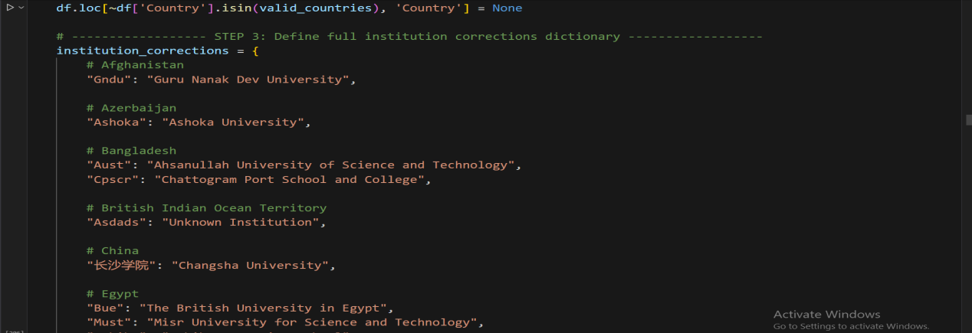

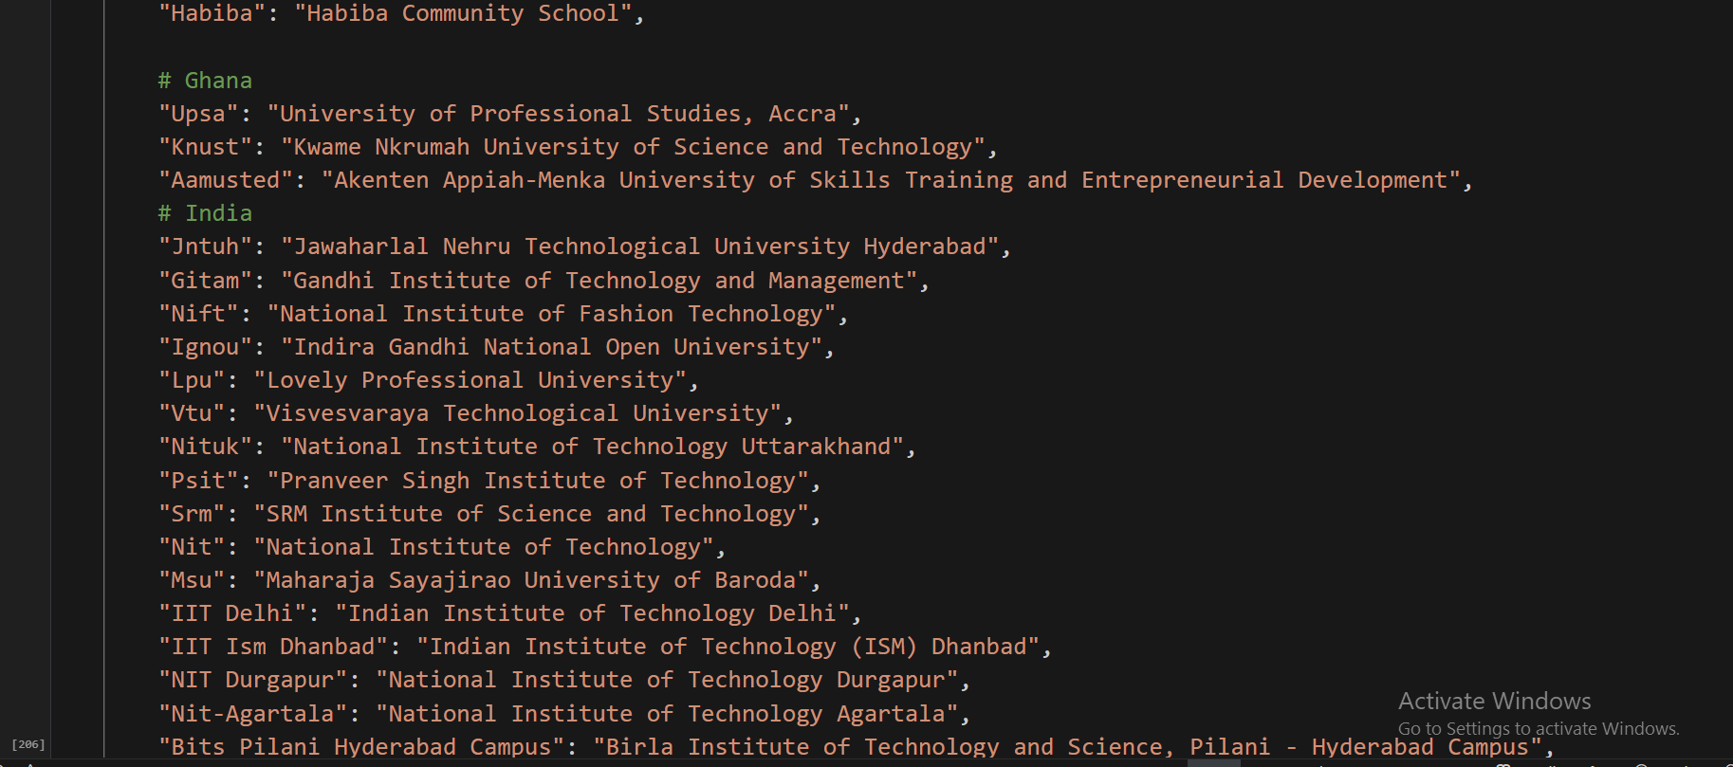

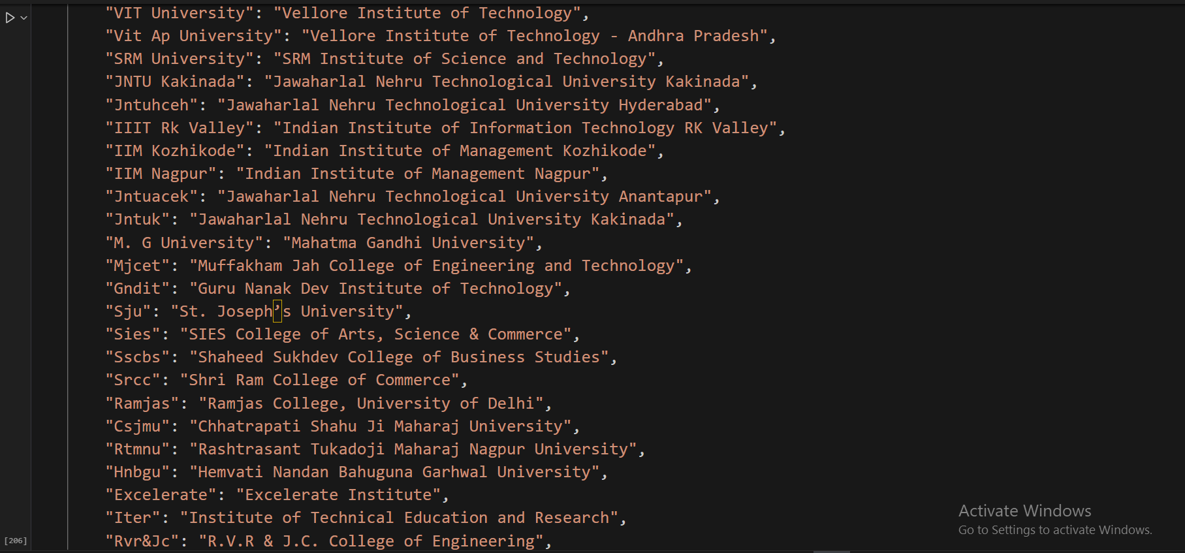

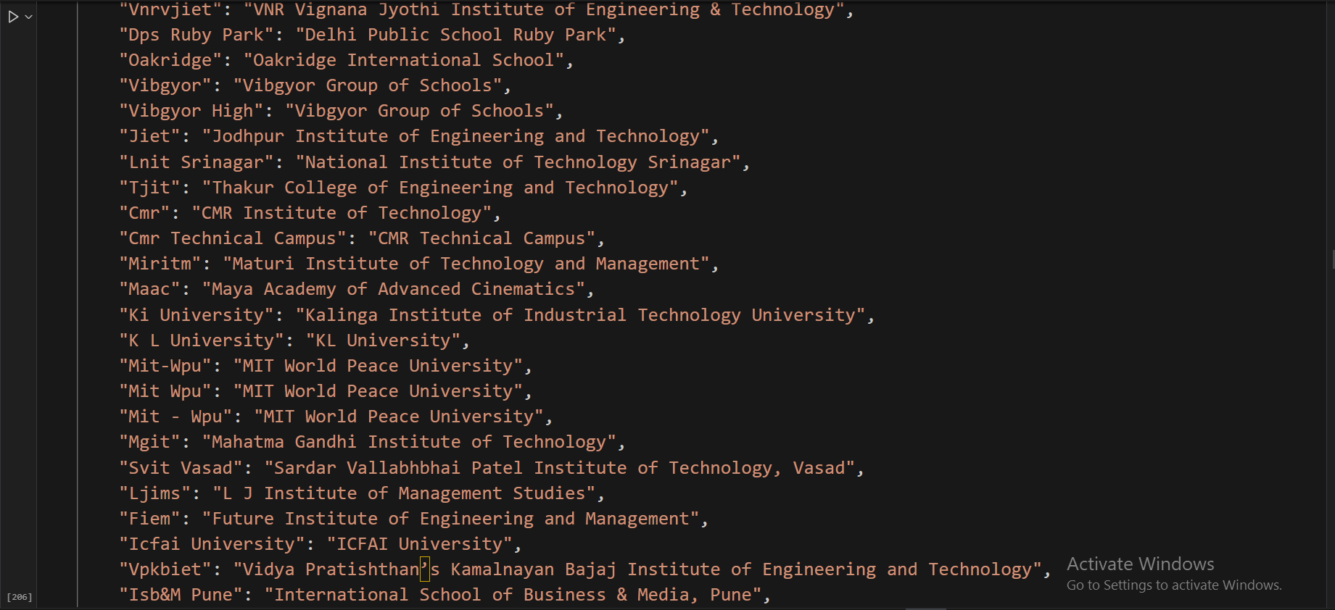

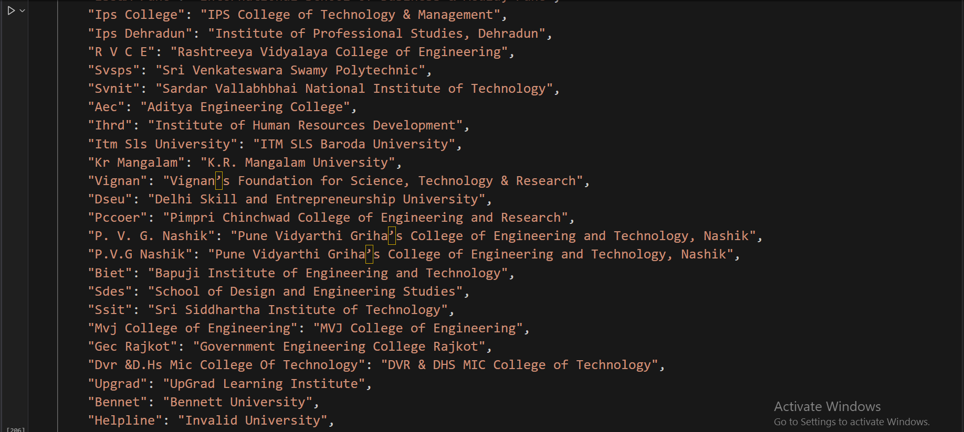

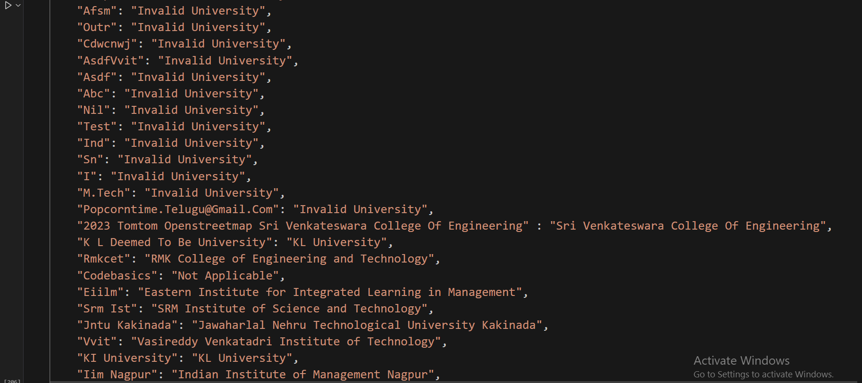

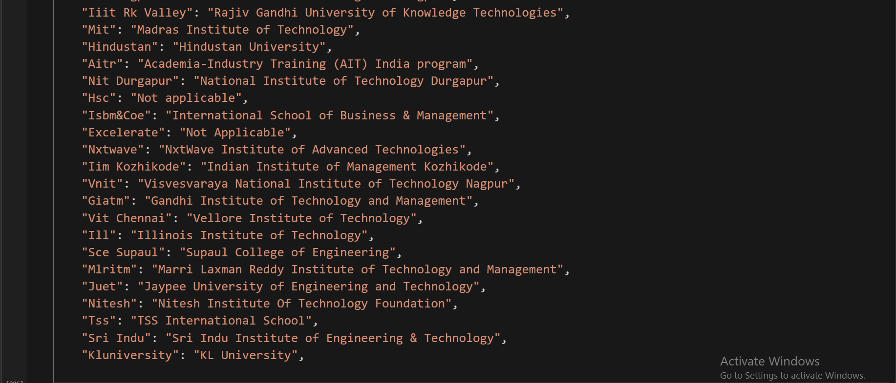

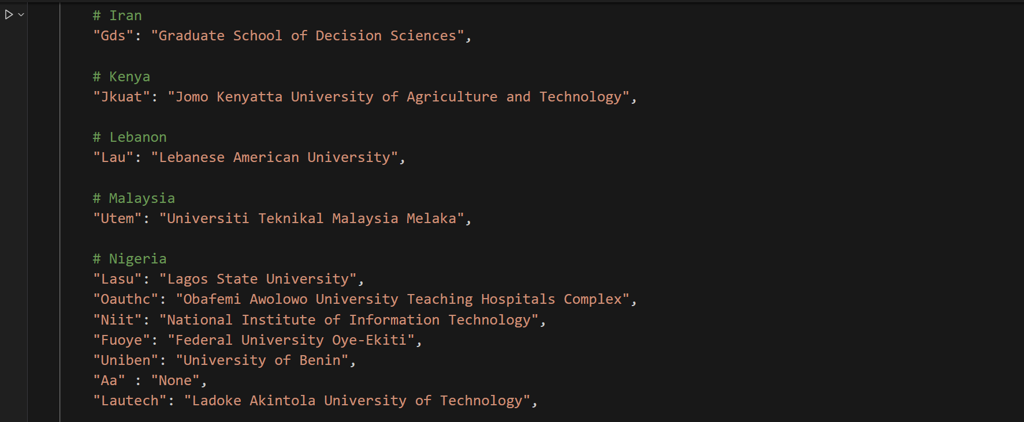

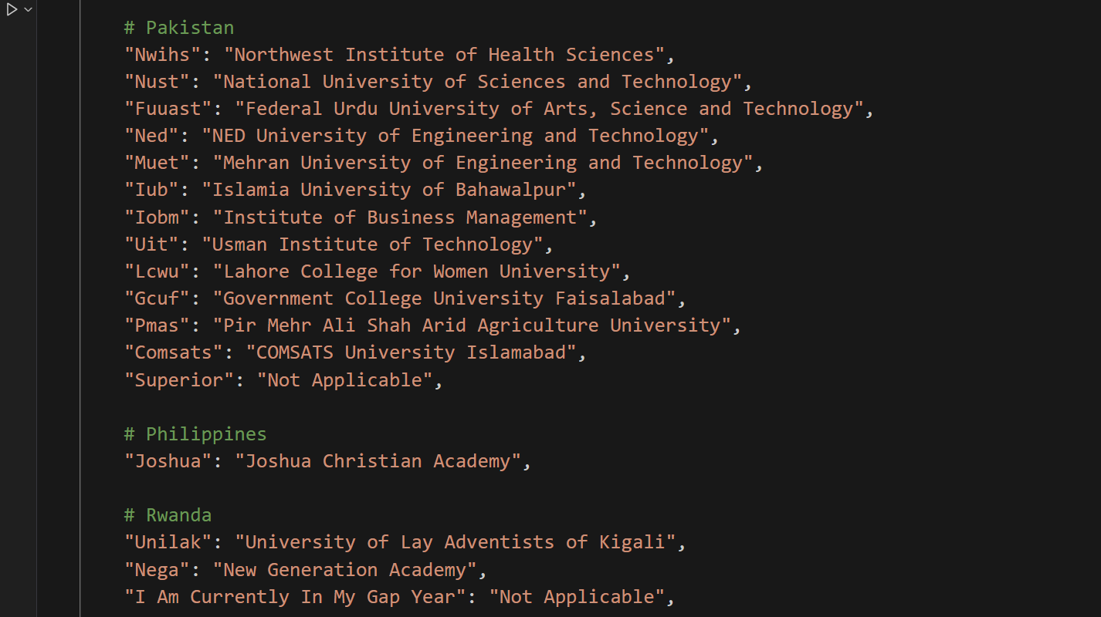

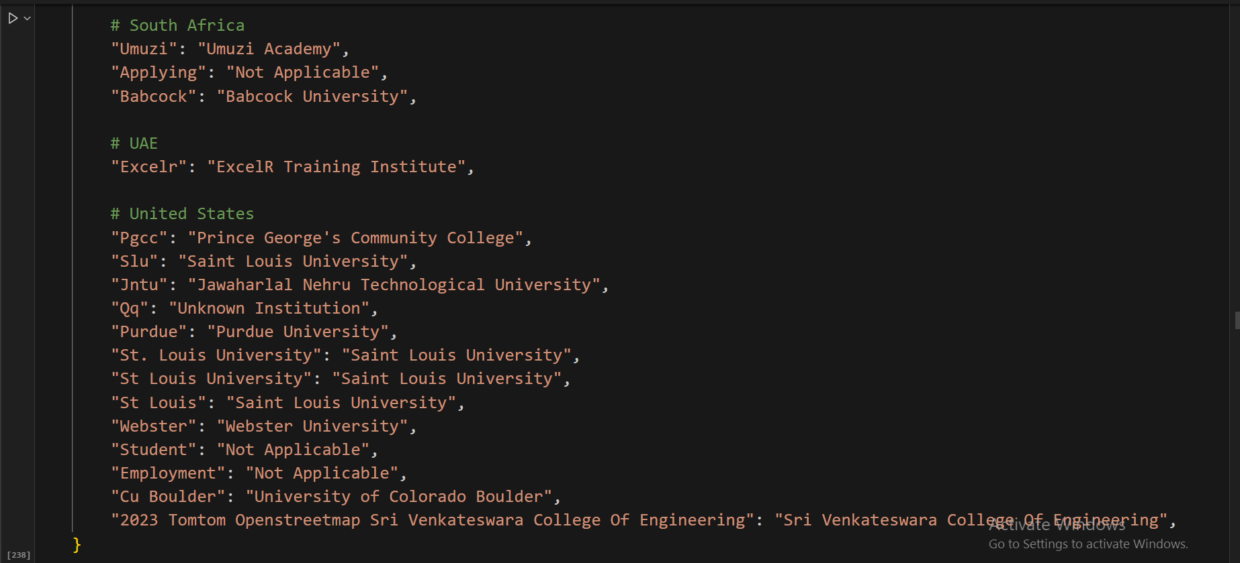

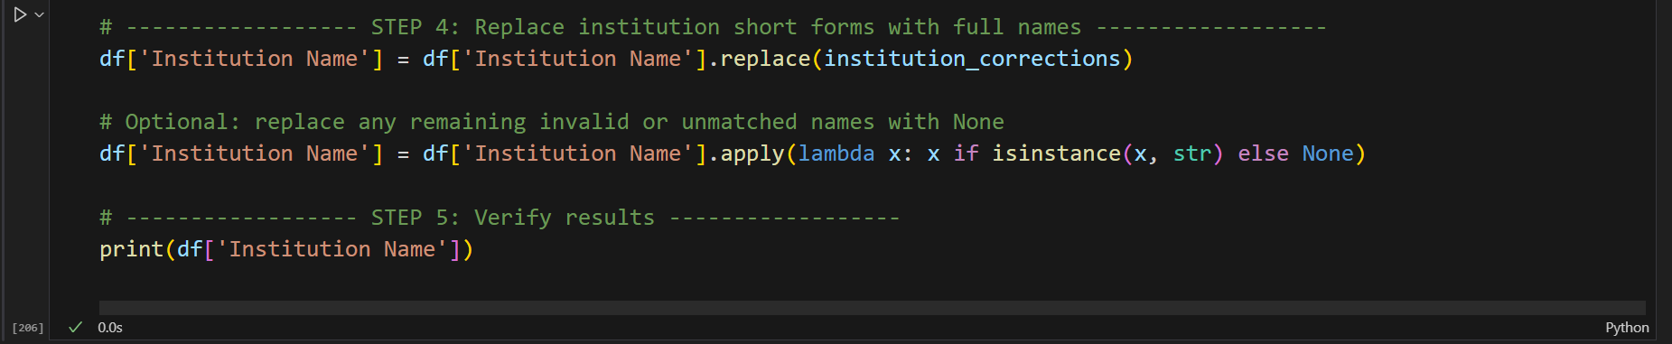

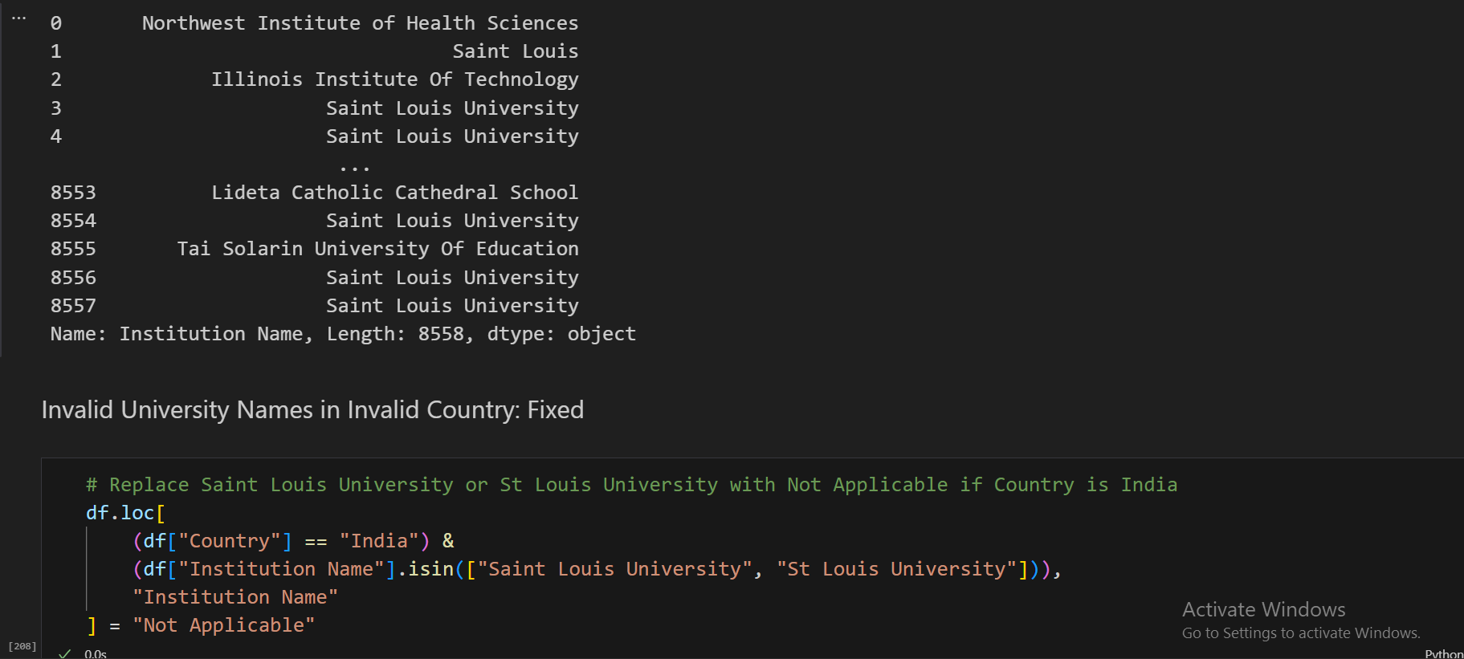

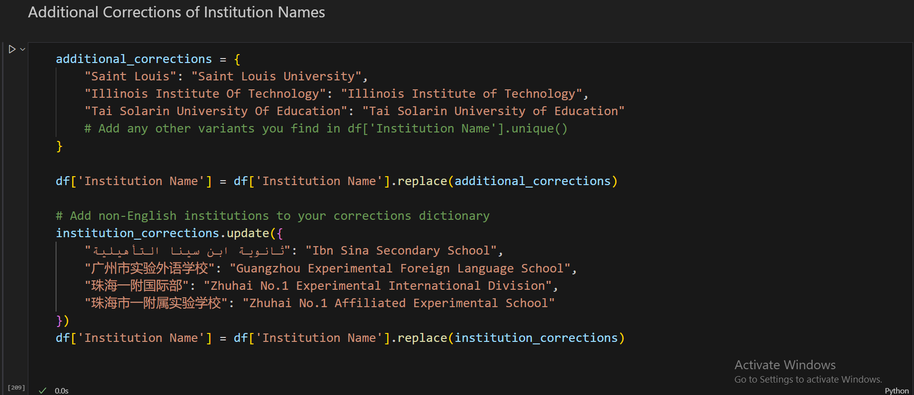

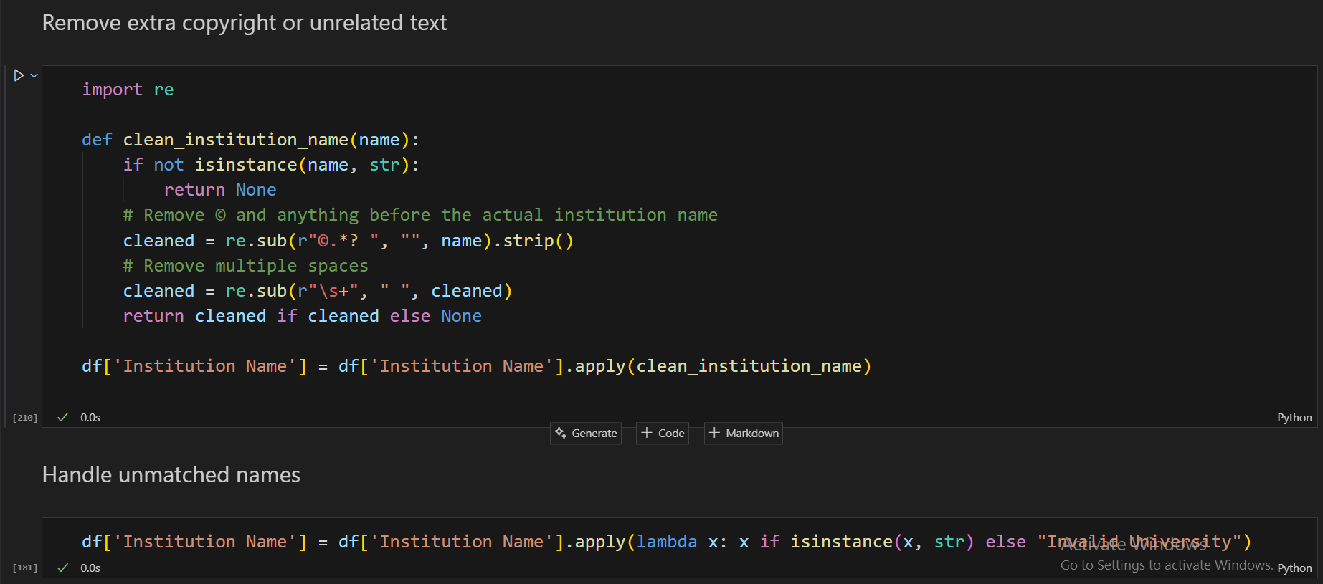

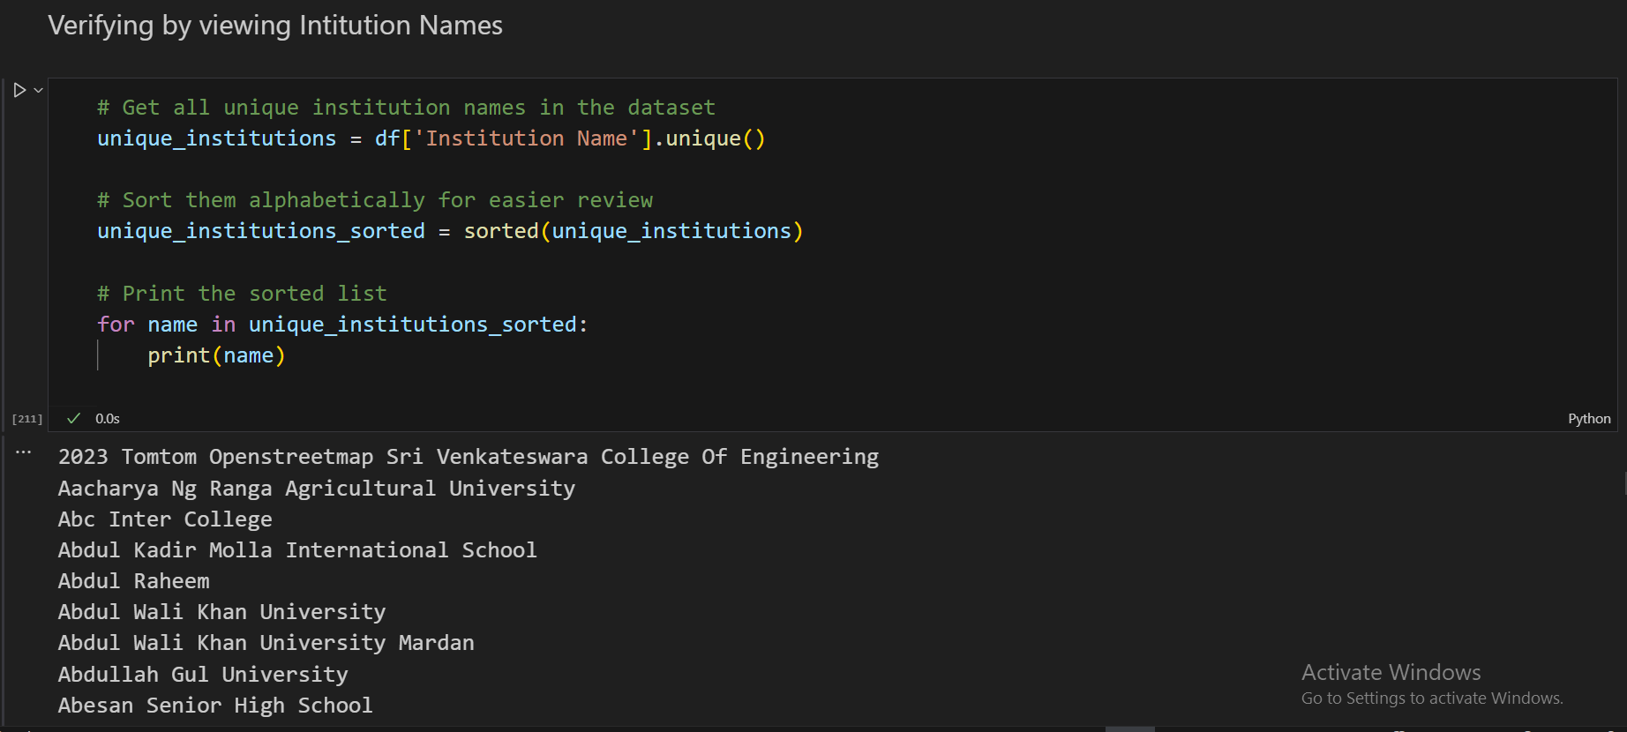

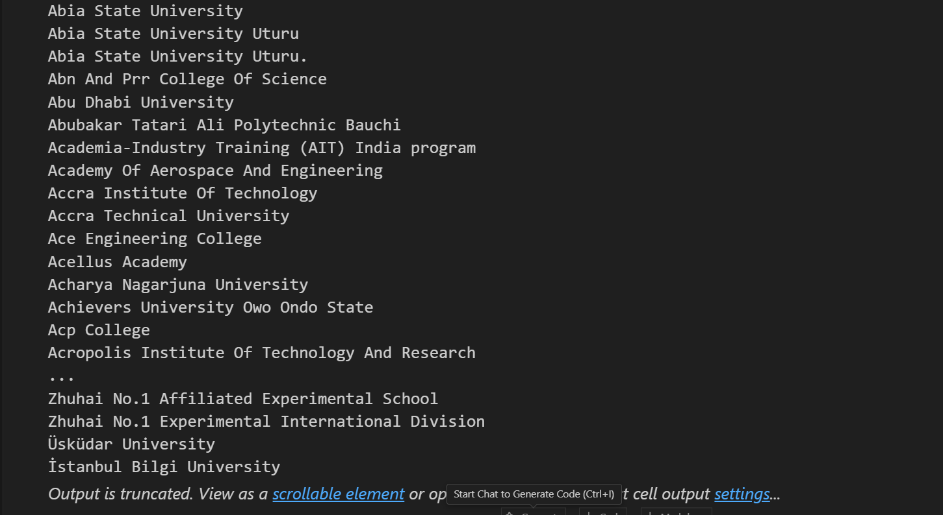

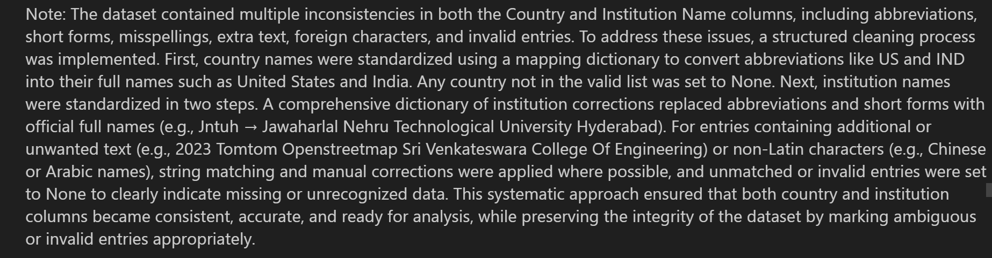

1. **Dealing with Duplicates:**

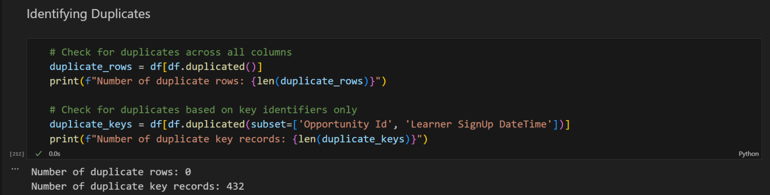

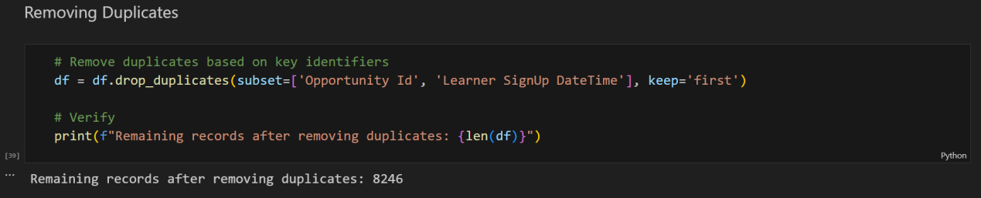

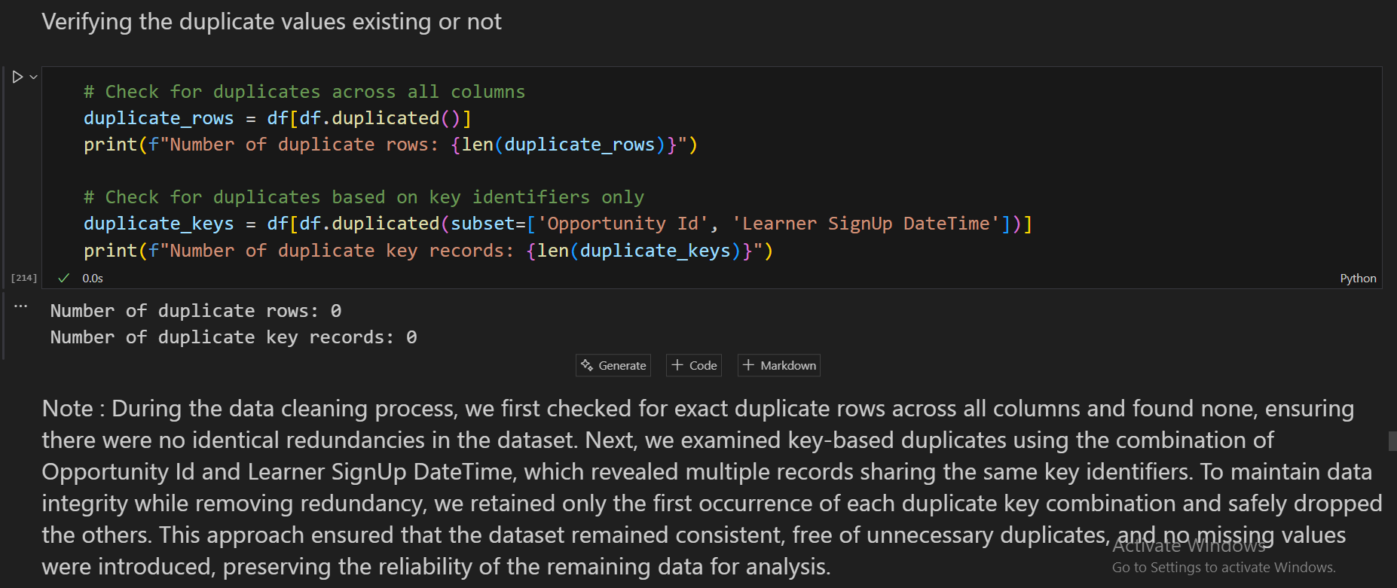

1. **Handling Inconsistent Categorical Data:**

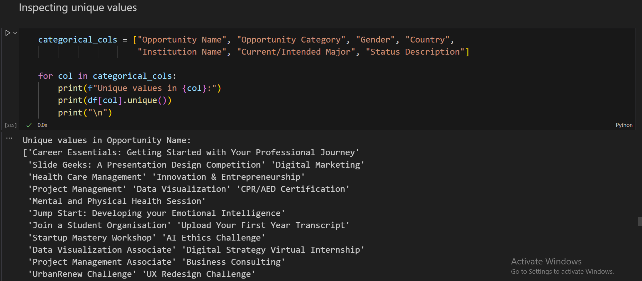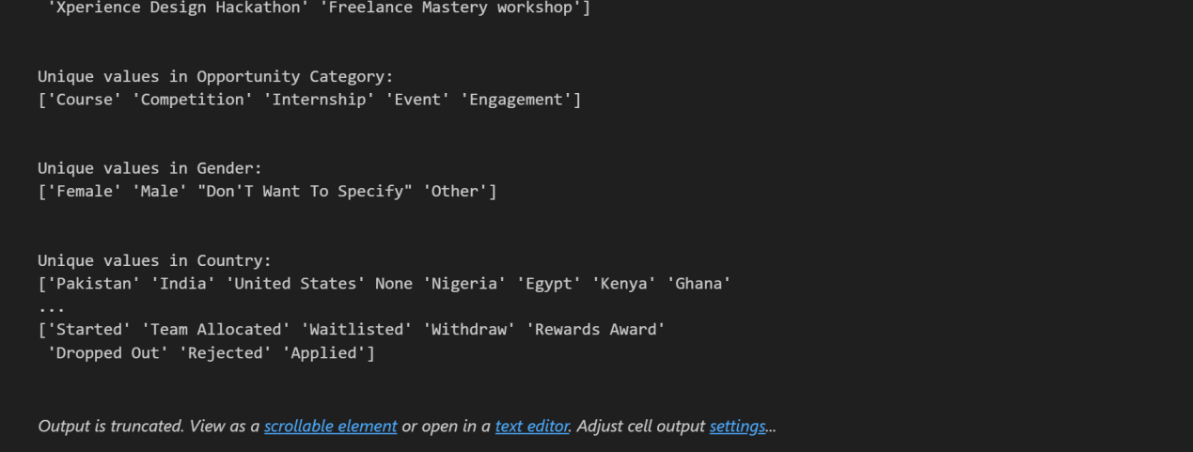

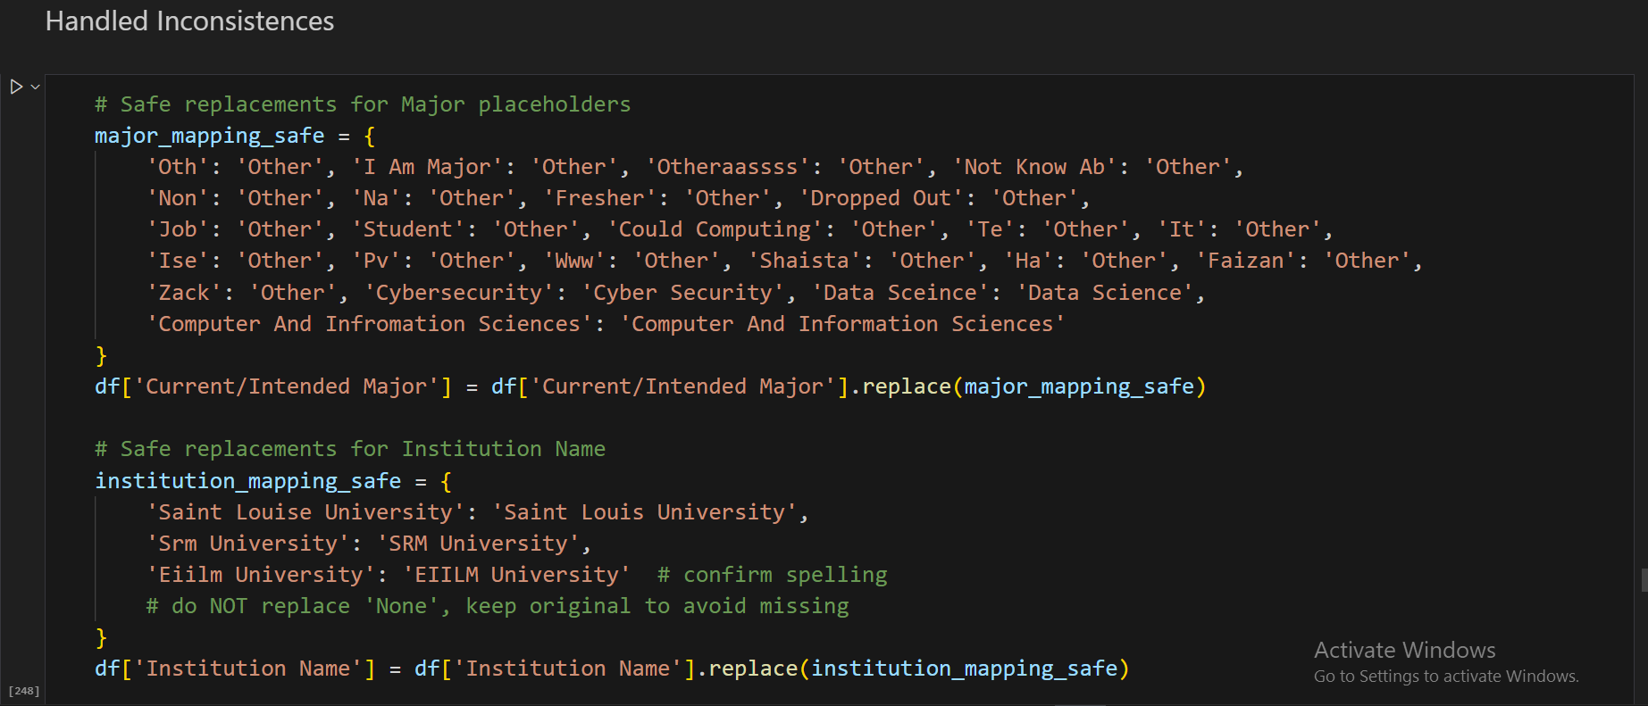

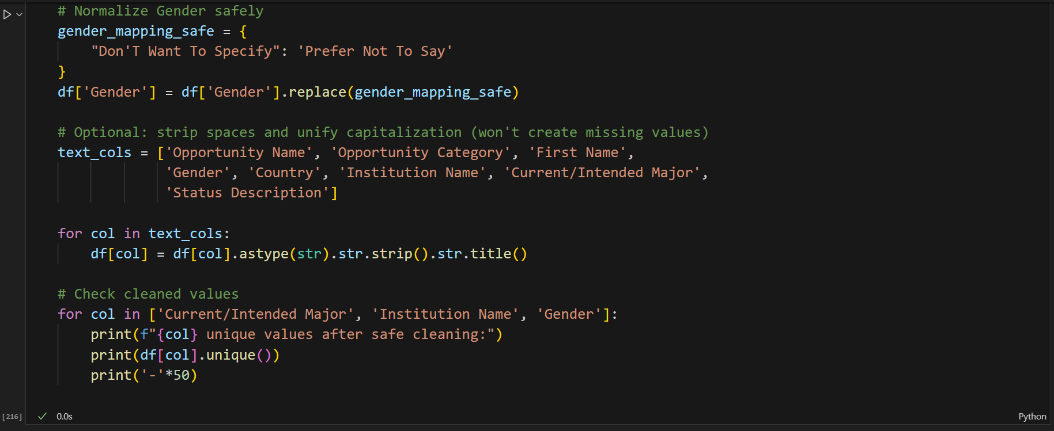

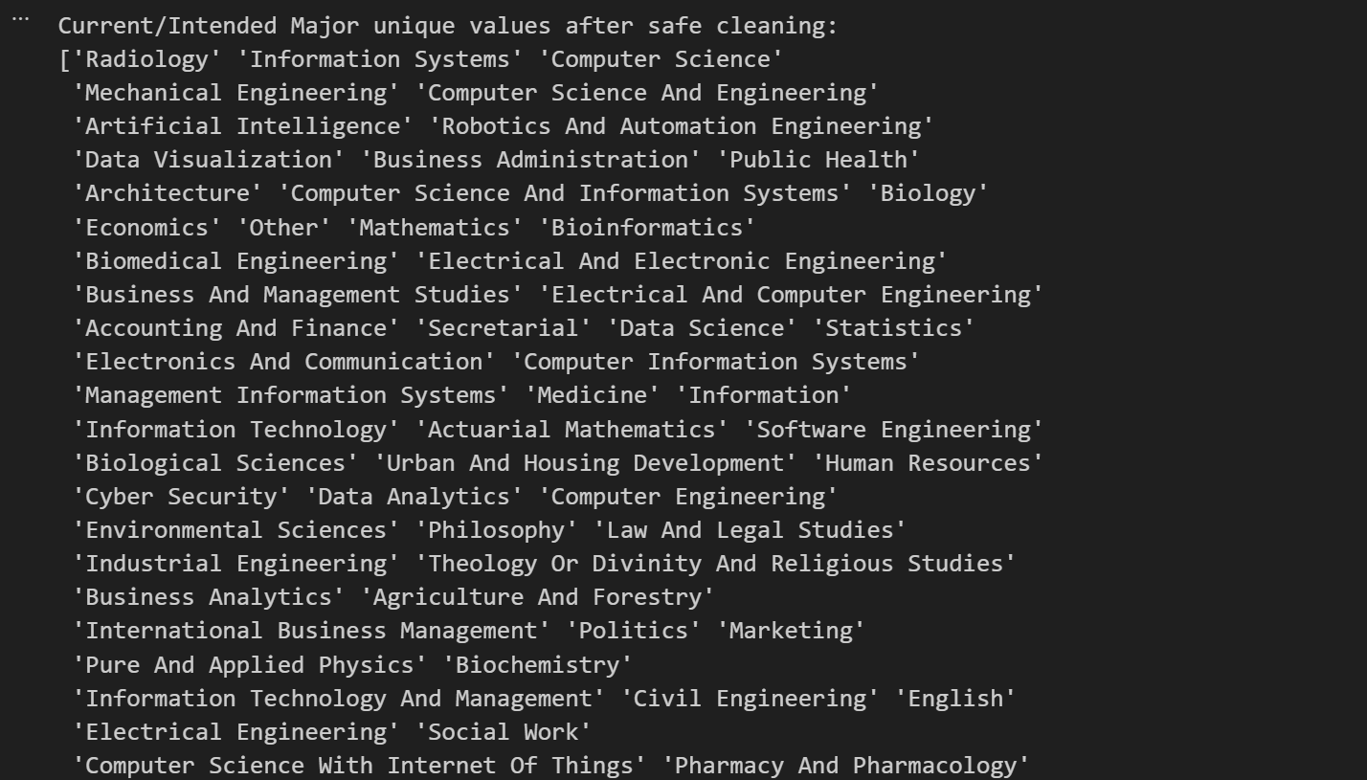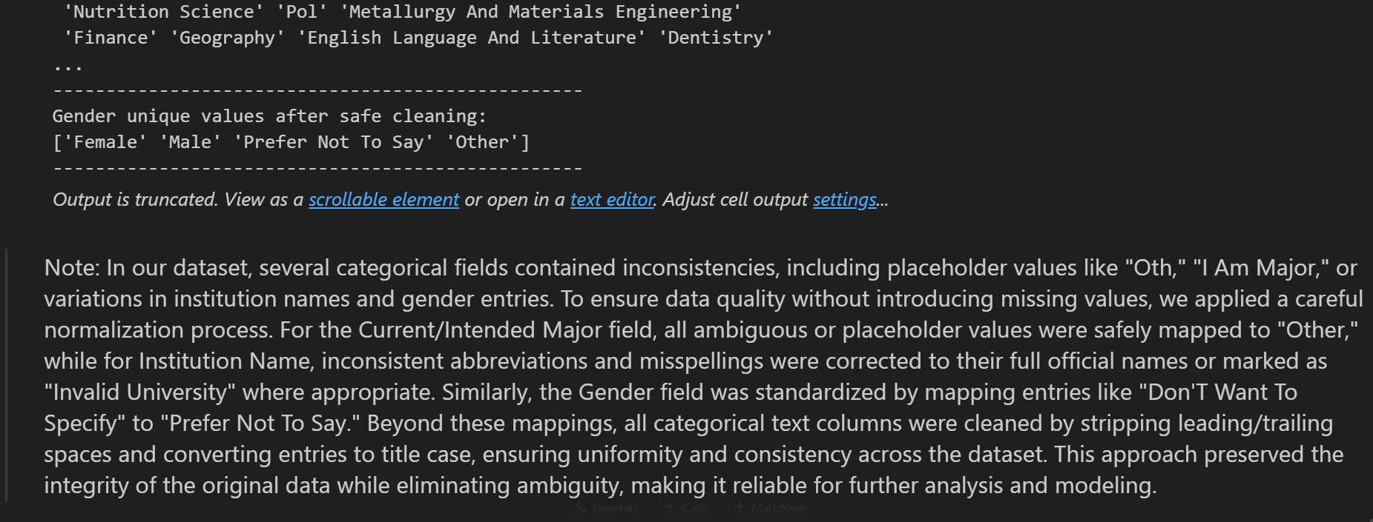

**Exporting Cleaned Dataset:**

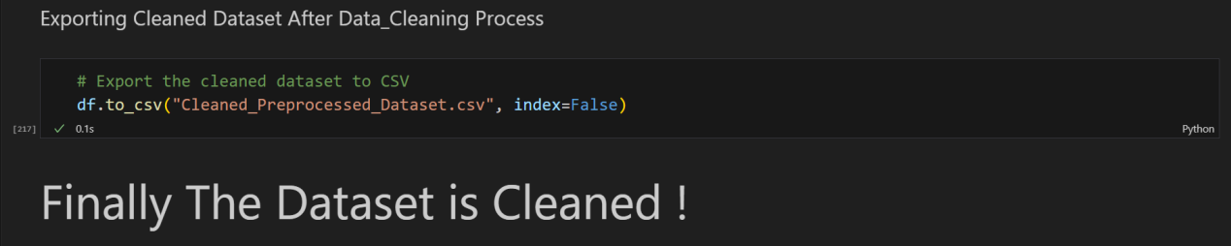

**Data Validation:**

| **Step No.** | **Data Cleaning Task** | **Columns Affected** | **Method / Action Taken** | **Purpose / Reason** |
| --- | --- | --- | --- | --- |
| 1 | Handling Missing Values | Institution Name, Current/Intended Major, Opportunity Start Date | Filled missing values with most frequent date for date column; others handled by replacing “None” value. | To ensure there are no missing entries that could affect analysis or modeling |
| 2 | Handling Outliers | Status Code | Identified numeric outliers using IQR; date outliers checked against realistic ranges; adjusted where necessary | To reduce distortion caused by extreme values |
| 3 | Standardizing Formats | Entry Created At | Was already converted in dataset of all date columns into uniform datetime64 format, ensuring consistency and preventing parsing errors. Didn’t needed to Standardize. | For maintain consistency for analysis and comparison |
| 4 | Standardizing Categorical Data | Opportunity Name, Opportunity Category, Gender, Country, Institution Name, Current/Intended Major, Status Description | Corrected capitalization, removed extra spaces, harmonized similar values (e.g., “st. louis” → “Saint Louis University”, “Don’T Want To Specify” → “Prefer Not To Say”) | To ensure uniform representation of categorical values |
| 5 | Correcting Errors | Institution Name, Current/Intended Major, Country | Fixed typographical errors, expanded abbreviations (e.g., “Nwihs” → “Northwest Institute of Health Sciences”), removed invalid entries (e.g., “xxxhhyy”) | To ensure data accuracy and reliability |
| 6 | Dealing with Duplicates | Entire dataset | Checked for duplicate rows and duplicate Opportunity Id + Learner SignUp DateTime; removed duplicates safely while keeping first occurrence | To avoid redundancy and maintain data integrity |
| 7 | Handling Inconsistent Categorical Data | Gender, Country, Institution Name, Current/Intended Major | Identified variations in categorical values, stripped extra spaces, and converted text to title case for consistency | To avoid inconsistent category representations during analysis |
| 8 | Institution-Specific Replacements | Country, Institution Name | Replaced "Saint Louis University" and "St Louis University" with "Not Applicable" when Country = India | To correct institution-country mismatches and ensure contextual accuracy |
| 9 | Fixing Corrupted Date Formats | Opportunity End Date, Opportunity Start Date, Learner SignUp DateTime,Apply Date | Applied custom parsing functions to handle mixed formats (e.g., Excel serial numbers like 45314, corrupted strings like 04/12/2024 1095120:00:00, and valid datetimes). Cleaned and standardized all values into datetime64[ns] with consistent “MM/DD/YYYY HH:MM:SS” format. | To ensure accurate temporal analysis, prevent errors in feature engineering (age, duration, engagement days), and maintain consistency across all date fields. |
| 10 | Verification | All columns | Checked final missing values, duplicates, date sequences, categorical consistency, and confirmed all date columns are in datetime64 format | To confirm dataset is clean, consistent, and ready for analysis |

**Total Records & Columns of Cleaned Dataset:**

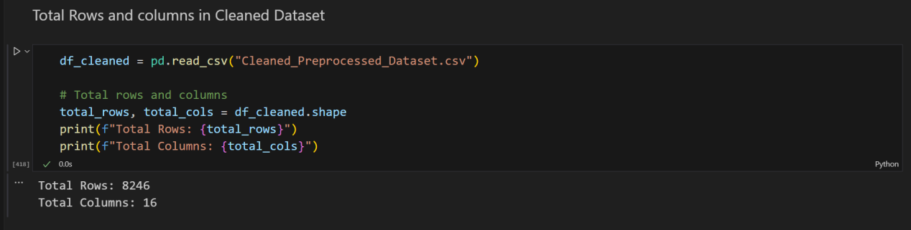

**Viewing First Few Rows of the Cleaned Dataset:**

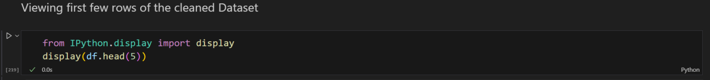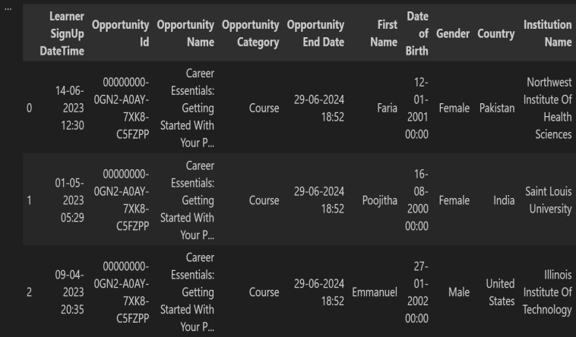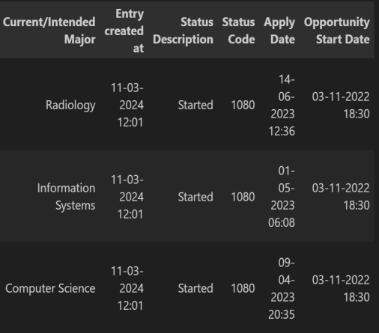

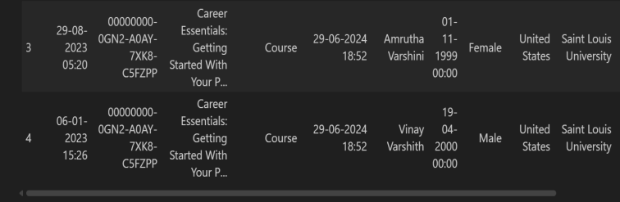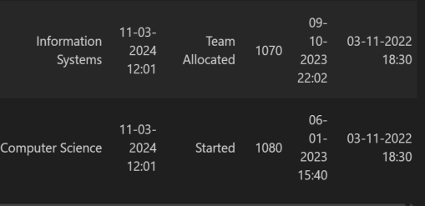

**You can view the cleaned and processed dataset at the following link:**

<https://drive.google.com/file/d/1kBs9lEZ9v4ffK6Jl3Jrd6YAPd755DHGD/view?usp=sharing>

‘

**Techniques For Feature Engineering**

Feature engineering is the process of transforming raw data into meaningful features that improve a model’s performance and predictive power. It is important because well-engineered features can significantly enhance accuracy and efficiency in machine learning tasks.

**Tools for Feature Engineering Using Excel:**

| **New Features** | **Section** | **Feature Name (Column Names)** | **Applied Formula** | **Formula Representation (Column meanings)** | **Why Used (Importance)** |
| --- | --- | --- | --- | --- | --- |
| Creating New Features | Age of Learner | Age | =DATEDIF(G2, TODAY(), "Y") | G2 → Date of Birth | Calculates learner’s current age. Helps analyze how engagement varies across age groups (e.g., younger vs. older learners). Useful for demographic insights and tailoring opportunities. |
| Creating New Features | Engagement Duration | Engagement Days | =ABS(O2 - P2) | O2 → Apply Date, P2 → Opportunity Start Date | Measures lag between application and opportunity start. Identifies quick vs delayed engagement, which helps uncover friction or motivation factors. |
| Creating New Features | Opportunity Duration | Opportunity Duration | =ABS(E2 - P2) | E2 → Opportunity End Date, P2 → Opportunity Start Date | Captures how long an opportunity lasts. Useful to assess whether longer/shorter opportunities affect learner participation and satisfaction. |
| Transforming Existing Features | Normalization of Metrics | Normalized Opportunity Duration | =ABS((R2 - MIN(R$2:R$100)) / (MAX(R$2:R$100) - MIN(R$2:R$100))) | R2 → Opportunity Duration | Scales durations between 0–1 for comparability. Prevents large numerical ranges from dominating analysis or models. |
| Transforming Existing Features | Normalization of Metrics | Normalized Status Code | =ABS((N2 - MIN(N$2:N$100)) / (MAX(N$2:N$100) - MIN(N$2:N$100))) | N2 → Status Code | Normalizes categorical status codes into a 0–1 range, enabling fair comparison and use in models without scale distortion. |
| Transforming Existing Features | Encoding Categorical Data | Encoded Gender | =IF(H2="Male", 1, IF(H2="Female", 2, 3)) | H2 → Gender | Converts gender into numerical format. Prepares gender data for ML models and prevents text-related inconsistencies. |
| Transforming Existing Features | Encoding Categorical Data | Encoded Country | =IF(I2="India", 1, IF(I2="United States", 2, IF(I2="Canada", 3, 4))) | I2 → Country | Converts country into numeric codes. Allows easier grouping, analysis, and modeling of country-specific patterns. |
| Transforming Existing Features | Encoding Categorical Data | Encoded Opportunity Category | =IF(D2="Internship", 1, IF(D2="Training", 2, IF(D2="Scholarship", 3, 4))) | D2 → Opportunity Category | Represents opportunity types numerically. Enables predictive analysis of how different categories impact engagement. |
| Extracting Useful Components | Date-Based Features | Extracted Month | =MONTH(A2) | A2 → Learner SignUp DateTime | Extracts month of learner sign-up. Useful for trend and seasonality analysis. |
| Extracting Useful Components | Date-Based Features | Extracted Year | =YEAR(A2) | A2 → Learner SignUp DateTime | Captures the year of sign-up. Helps in long-term trend analysis. |
| Extracting Useful Components | Date-Based Features | Extracted Day | =DAY(A2) | A2 → Learner SignUp DateTime | Extracts day of the month. Enables fine-grained daily engagement insights. |
| Extracting Useful Components | Date-Based Features | Weekly Patterns | =WEEKDAY(A2,2) | A2 → Learner SignUp DateTime | Captures day of the week (1=Mon…7=Sun). Helps detect weekday vs weekend sign-up patterns. |
| Combining Features | Interaction Features | Duration × Age | =ABS(Q2 * R2) | Q2 → Age, R2 → Opportunity Duration | Multiplies learner’s age with opportunity duration. Explores combined effects of demographic and opportunity length on engagement. |
| Combining Features | Engagement Scores | Engagement Score | =S2*0.4 + Q2*0.2 + AA2*0.3 + AB2*0.1 | S2 → Normalized Opportunity Duration, Q2 → Age, AA2 → Engagement Days, AB2 → Duration × Age | Weighted composite score combining multiple engagement metrics. Provides a single holistic measure of overall engagement. |
| Temporal Analysis | Seasonal Patterns | Seasonal Pattern | =IF(OR(X2=12,X2<=2),"Winter", IF(X2<=5,"Spring", IF(X2<=8,"Summer","Fall"))) | X2 → Extracted Month | Groups months into four seasons. Helps identify seasonal peaks/troughs in engagement and optimize scheduling of opportunities. |

*Note : In few formulas, we used the ABS() function to prevent negative values from appearing in the results. Throughout the process, we ensured that no original data values were altered; instead, we focused on correcting formats and standardizing the dataset through data cleaning.*

**You can view the featured dataset at the following link:**

<https://drive.google.com/file/d/1ltU9enu7mf7U72PUcTcBFUWvRRttFFUB/view?usp=sharing>

**Viewing First Few Rows of the “Featured_Dataset.csv” :**

*(Only those columns where features are used)*

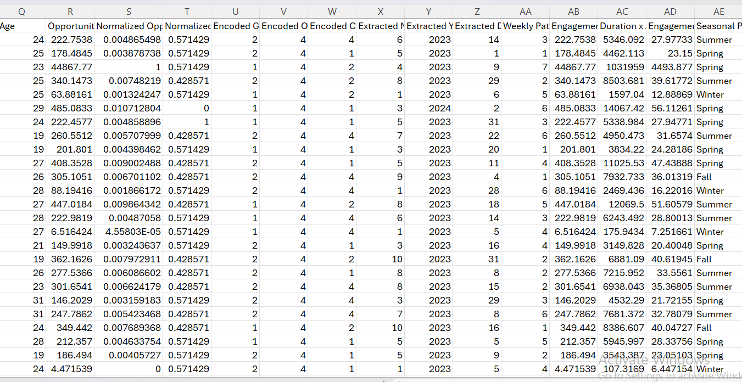

**Conclusion**

In the first week of the AI Data Powered Analysis Early Internship, we successfully built a strong foundation in data preprocessing and feature engineering. The raw dataset, “SLU_Opportunity_Wise_Data.csv”, was carefully explored to identify and address missing values, outliers, duplicates, and inconsistencies. Through systematic data cleaning steps, including handling corrupted date formats, standardizing categorical fields, and ensuring logical consistency in timelines, the dataset was transformed and exported as “Cleaned_Preprocessed_Dataset.csv”.

Building on this cleaned dataset, we applied feature engineering techniques to derive meaningful new insights, such as learner age, opportunity duration, engagement days, and seasonal patterns. Normalization and categorical encoding were also implemented to ensure features were consistent and analysis-ready. The engineered dataset was then saved as “Featured_Dataset.csv”, providing a structured and enriched resource for advanced engagement analysis.

Overall, Week 1 provided valuable experience in practical data cleaning and transformation using both Python and Excel. The outcomes of this stage—clean data, enriched features, and well-documented processes—serve as a strong foundation for deeper analysis and predictive modeling in the subsequent phases of the internship.

**Next Steps for week-2:**

· We will examine the cleaned dataset to understand its structure and key features.

· We will identify patterns, trends, and any unusual data points.

· We will create charts and graphs to represent the data visually.

· We will extract important insights and observations from the information.

· We will propose possible explanations or predictions based on the findings.

· We will compile all results, visuals, and hypotheses into an EDA report.

· We will get the dataset ready for AI analysis and predictive modeling in the upcoming weeks.